Finite Fields and Field Operators

Introduction
In this chapter finite fields and finite field arithmetic operators are introduced. The definitions and main results underlying finite field theory are presented and it is shown how to derive extension fields. The various finite field arithmetic operators are reviewed. In addition, new circuits are presented carrying out frequently used arithmetic operations in decoders. These operators are shown to have faster operating speeds and lower hardware requirements than their equivalents and consequently have been used extensively throughout this project.

Finite fields
Error control codes rely to a large extent on powerful and elegant algebraic structures called finite fields. A field is essentially a set of elements in which it is possible to add, subtract, multiply and divide field elements and always obtain another element within the set. A finite field is a field containing a finite number of elements. A well known example of a field is the infinite field of real numbers.

Field definitions and basic features
The concept of a field is now more formally introduced. A field F is a non-empty set of elements with two operators usually called addition and multiplication, denoted ‘+’ and ‘*’ respectively. For F to be a field a number of conditions must hold [5,29]:

1. Closure: For every a, b in F
c = a + b; d = a * b; (2.1)
where c, d ∈ F.
2. Associative: For every a, b, c in F
a + (b + c) = (a + b) + c and a * (b * c) = (a * b) * c. (2.2)
3. Identity: There exists an identity element ‘0’ for addition and ‘1’ for multiplication that satisfy
0 + a = a + 0 = a and a * 1 = 1 * a = a (2.3)
for every a in F.
4. Inverse: If a is in F, there exist elements b and c in F such that
a + b = 0 a * c = 1. (2.4)
Element b is called the additive inverse, b = (-a), element c is called the multiplicative inverse, c = a⁻¹ (a≠0).
5. Commutative: For every a, b in F
a + b = b + a a * b = b * a. (2.5)
6. Distributive: For every a, b, c in F
(a + b) * c = a * c + b * c. (2.6)

The existence of a multiplicative inverse a⁻¹ enables the use of division. This is because for a,b,c ∈ F, c = b/a is defined as c = b * a⁻¹ . Similarly the existence of an additive inverse (-a) enables the use of subtraction. In this case for a,b,c ∈ F, c = b - a is defined as c = b + (-a).

It can be shown that the set of integers {0, 1, 2, ... , p-1} where p is a prime, together with modulo p addition and multiplication forms a field [30]. Such a field is called the finite field of order p, or GF(p), in honour of Evariste Galois [48]. In this thesis only binary arithmetic is considered, where p is constrained to equal 2. This is because, as shall be seen, by starting with GF(2), the representation of finite field elements maps conveniently into the digital domain. Arithmetic in GF(2) is therefore defined modulo 2. It is from the base field GF(2) that the extension field GF(2^{m}) is generated.

The extension field GF(2^{m})
Before introducing GF(2^{m}), some definitions are required. A polynomial p(x) of degree m over GF(2) is a polynomial of the form
p(x) = p₀ + p₁x + p₂x² + ... + p_{m}x^{m} (2.7)
where the coefficients p_{i} are elements of GF(2) = {0,1}. Polynomials over GF(2) can be added, subtracted, multiplied and divided in the usual way [29]. A useful property of polynomials over GF(2) is that ([29], pp.29)
p²(x) = ( p₀ + p₁x + ... +p_{n}x^{n})² = p₀ + p₁x² + ... + p_{n}x^{2n} = p(x²). (2.8)

The notion of an irreducible polynomial is now introduced.
Definition 2.1. A polynomial p(x) over GF(2) of degree m is irreducible if p(x) is not divisible by any polynomial over GF(2) of degree less than m and greater than zero.

To generate the extension field GF(2^{m}), an irreducible, monic polynomial of degree m over GF(2) is chosen, p(x) say. Then the set of 2^{m} polynomials of degree less than m over GF(2) is formed and denoted F. It can then be proven that when addition and multiplication of these polynomials is taken modulo p(x), the set F forms a field of 2^{m} elements, denoted GF(2^{m}) [30]. Note that GF(2^{m}) is extended from GF(2) in an analogous way that the complex numbers C are formed from the real numbers R where in this case, p(x) = x² + 1.

To represent these 2^{m} field elements, the important concept of a basis is now introduced.

The polynomial basis and primitive elements
Definition 2.2. A set of m linearly independent elements β ={β₀ ,β₁,..., β_{m-1}} of GF(2^{m}) is called a basis for GF(2^{m}).
A basis for GF(2^{m}) is important because any element a ∈ GF(2^{m}) can be represented uniquely as the weighted sum of these basis elements over GF(2). That is
a = a_{o}β₀ + a₁β₁ + .... + a_{m-1}β_{m-1} a_{i} ∈ GF(2). (2.9)
Hence the field element a can be denoted by the vector (a₀, a₁, ..., a_{m-1}). This is why the restriction p = 2 has been made, since the above representation maps immediately into the binary field.

There are a large number of possible bases for any GF(2^{m}) [30]. One of the more important bases is now introduced.

Definition 2.3. Let p(x) be the defining irreducible polynomial for GF(2^{m}). Take α as a root of p(x), then A = {1,α,...α^{m-1}} is the polynomial basis for GF(2^{m}).

For example consider GF(2⁴) with p(x) = x⁴ + x + 1. Take α as a root of p(x) then A = {1,α,α²,α³} forms the polynomial basis for this field and all 16 elements can be represented as
a = a₀ + a₁α + a₂α² + a₃α³ (2.10)
where the a_{i} ∈ GF(2). These basis coefficients can be stored in a basis table of the kind shown in Appendix B.

Definition 2.4. An irreducible polynomial of degree m is a primitive polynomial if the smallest positive integer n for which p(x) divides x^{n} + 1 is n = 2^{m} - 1.

If α is a root of p(x) where this polynomial is not only irreducible but also primitive, then GF(2^{m}) can be represented alternatively by the set of elements GF(2^{m}) = {0,1,α,α², ... α^{n-1}}, (n = 2^{m} -1 ). In this case α is called a primitive element and α^{n} = 1. The relationship between powers of primitive elements and the polynomial basis representation of GF(2⁴) is also shown in Appendix B.

The choice as to whether to represent field elements over a basis or as powers of a primitive element usually depends on whether a hardware or a software implementation is being adopted. This is because α^{i} * α^{j} = α^{i +j} , where this indices addition is modulo 2^{m}-1 and so can easily be carried out on a general purpose computer. Multiplication of field elements using the primitive element representation is therefore simple to implement in software, but addition is much more difficult. For implementation in hardware however a basis representation of field elements makes addition relatively straight forward to implement. This is because
a = b + c = (b₀ + b₁α + ... + b_{m-1} α^{m-1} ) + (c₀ + c₁α + ... + c_{m-1} α^{m-1} ) =
= (b₀ + c₀) + (b₁ + c₁)α + ... + (b_{m-1} + c_{m-1}) α^{m-1} (2.11)
and so addition is performed component-wise modulo 2. Hence a GF(2^{m}) adder circuit comprises 1 or m XOR gates depending on whether the basis coefficients are represented in series or parallel. This is an important feature of GF(2^{m}) and one of the main reasons why finite fields of this form are so extensively used.

The Dual Basis
The dual basis is an important concept in finite field theory and was originally exploited to allow for the design of hardware efficient RS encoders [3]. However subsequent research has allowed the use of dual basis multipliers to be adopted throughout the encoding and decoding processes.

Definition 2.5. [15] Let {λ_{i}} and {μ_{i}} be bases for GF(2^{m}), let f be a linear function from GF(2^{m}) → GF(2), and β∈ GF(2^{m}), β≠0. Then {λ_{i}} and {μ_{i}} are dual to each other with respect to f and β if
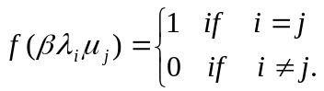 (2.12)
In this case, {λ_{i}} is the standard basis and {μ_{i}} is the dual basis.

Theorem 2.1. [15]. Every basis has a dual basis with respect to any non-zero linear function f: GF(2^{m}) → GF(2), and any non-zero β∈ GF(2^{m}).

For example consider GF(2⁴) with p(x) = x⁴ + x + 1 and take α as a root of p(x). Then {1,α,α²,α³} is the polynomial basis for the field. Now taking β = 1 and f to be the least significant polynomial basis coefficient, {1,α³,α²,α} forms the dual basis to the polynomial basis. In fact by varying β there are 2^{m}-1 dual bases to any given basis and the dual basis with the most attractive characteristics can be taken. This is usually taken to mean the dual basis that can be obtained from the polynomial basis with the simplest linear transformation [38].

Normal basis
A normal basis for GF(2^{m}) is a basis of the form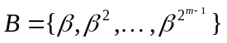where β ∈ GF(2^{m}). For every finite field there always exists at least one normal basis [30]. Normal basis representations of field elements are especially attractive in situations where squaring is required, since if (a₀, a₁, ... ,a_{m-1}) is the normal basis representation of a ∈ GF(2^{m}) then (a_{m-1}, a₀, a₁, ... , a_{m-2}) is the normal basis representation of a² [31]. This property is important in its own right but also because it allows for hardware efficient Massey-Omura multipliers to be designed. The normal basis representation of GF(2⁴) is given in Appendix B.

Multiplication by a constant α^{j}
It is frequently required to carry out multiplication by a constant value in encoders and decoders. This can be accomplished using two-variable input multipliers of the type described later. Alternatively it is often beneficial to employ a multiplier designed specifically for this task ([29], p. 162) ([30], p.89).
Let a = a₀ + a₁α + ... + a_{m-1}α^{m-1} be an element in GF(2^{m}) where α is a root of the primitive polynomial p(x) = x^{m} +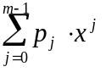. Thus
a * α = a₀α + a₁α² + ... + a_{m-1}α^{m} (2.13)
but since p(α) = 0
a*α = a₀α + a₁α² + ... + a_{m-2}α^{m-1} + a_{m-1}(p₀ + p₁α +p₂α² + ... + p_{m-1}α^{m-1}) (2.14)
which is equivalent to a*α mod p(α).

For example consider, multiplication by α in GF(2⁴), where p(x) = x⁴ + x + 1. Then
a*α = a₃ + (a₃ + a₀)α + a₁α² + a₂α³ (2.15)
and this multiplication can be carried out with the following circuit.
A₃
A₂
A₁
A₀

Figure 2.1. Circuit for computing a ← a * α in GF(2⁴).

If the above register is initialised by A_{i} = a_{i} (i=0,1,2,3) then by clocking the register once, the value of a*α is generated. This algorithm may be readily extended for multiplication by α^{j}, where j is any integer and for any GF(2^{m}).

Bit-serial multiplication
The most commonly implemented finite field operations are multiplication and addition. Multiplication is considered to be a degree of magnitude more complicated than addition and a large body of research has been carried out attempting to reduce the hardware and time complexities of multiplication. Finite field adders and multipliers can be classified according to whether they are bit-serial or bit-parallel, that is whether the m bits representing field elements are processed in series or in parallel. Whereas bit-serial multipliers generally require less hardware than bit-parallel multipliers, they also usually require m clock cycles to generate a product rather than one. Hence in time critical applications bit-parallel multipliers must be implemented, in spite of the increased hardware overheads.

Berlekamp multipliers
The Berlekamp multiplier [3] uses two basis representations, the polynomial basis for the multiplier and the dual basis for the multiplicand and the product. Because it is normal practice to input all data in the same basis, this means some basis transformation circuits will be required. Fortunately for m = (3, 4, 5, 6, 7, 9, 10) the basis conversion from the dual to the polynomial basis - and vice versa - is merely a reordering of the basis coefficients [38]. For the important case m = 8 - for example the error-correcting systems used in CDs, DAT and many other applications operate over GF(2⁸) - this basis conversion requires a reordering and two additions of the basis coefficients (Appendix C). In practice therefore, two additional XOR gates are required. Even including the extra hardware for basis conversions, the Berlekamp multiplier is known to have the lowest hardware requirements of all available bit-serial multipliers [24].

Now let a, b, c ∈ GF(2^{m}) such that c = a * b and represent b over the polynomial basis as b = 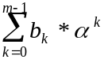. Further, and following Definition 2.5, let {μ₀, μ, ..., μ_{m-1},} be the dual basis to the polynomial basis for some f and β. Hence 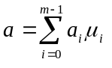 and 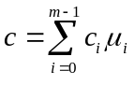 where these values of a_{i} and c_{i} are given by the following.

Lemma 2.1 [15]. Let {μ₀, μ₁, ..., μ_{m-1}} be the dual basis to the polynomial basis for GF(2^{m}) for some f and β and let a =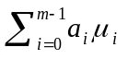 be the dual basis representation of a ∈ GF(2^{m}). Then a_{i} = f(aβα^{i}) for (i=0,1, ..., m-1).

The multiplication c = a*b can therefore be represented in the matrix form [15]
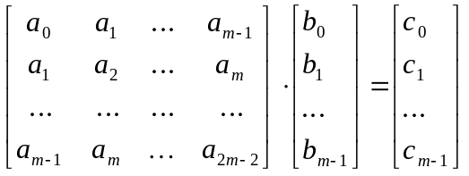 (2.16)

where a_{i} = f(aβα^{i}) and c_{i} = f(cβα^{i}) (i = 0,1, ..., m-1) are the dual basis coefficients of a and c respectively and a_{i} = f(aβα^{i}) (i=m, m+1,..., 2m-2). It can be shown [15] that
a_{m+k} = f(aβα^{m+k} ) = 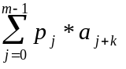 (k= 0,1, .....) (2.17)
where the p_{j} are the coefficients of p(x). These values of a_{m+k} can therefore be obtained from an m-stage linear feedback shift register (LFSR) where the feedback terms correspond to the p_{j} coefficients and the LFSR is initialised with the dual basis coefficients of a. On clocking the LFSR a_{m} is generated, then on the next clock cycle a_{m+1} is produced, and so on. The m vector multiplications listed in equ(2.16) are then carried out by a structure comprising m 2-input AND gates and (m-1) 2-input XOR gates. As an example, a Berlekamp multiplier for GF(2⁴) is shown in Fig. 2.2 where p(x) = x⁴ + x + 1.
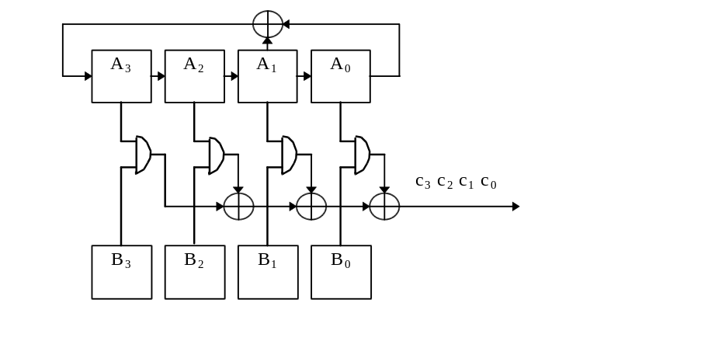
Figure 2.2 Bit-serial Berlekamp multiplier for GF(2⁴).

The registers in Fig. 2.2 are initialised by A_{i} = a_{i} and B_{i} = b_{i} for (i= 0,1,2,3). At this point the first product bit c₀ is available on the output line. The remaining values of c_{1,} c₂ and c₃ are obtained by clocking the register a further three times.

With the above scheme at least one basis conversion is required if both inputs and the output are to be represented over the same basis. This basis transformation is a linear transformation of the basis coefficients and can be implemented within the multiplier structure itself. However with GF(2⁴) the dual basis is a permutation of the polynomial basis coefficients and so this conversion can be implemented by a simple reordering of the inputs.

Massey-Omura Multiplier
The Massey-Omura multiplier [31,54] operates entirely over the normal basis and so no basis converters are required. The idea behind the Massey-Omura multiplier is that if the Boolean function generating the first product bit has the inputs cyclically shifted, then this same function will also generate the second product bit. Furthermore with each subsequent cyclic shift a further product bit is generated. Hence instead of m Boolean functions, one Boolean function is required to generate all m product bits but with the inputs to this function shifted each clock cycle.

As an example, consider a Massey-Omura bit-serial multiplier for GF(2⁴). Let α be a root of p(x) = x⁴ + x + 1 and let a normal basis for the field is {α³, α⁶, α¹², α⁹}. Further, let such that c = a*b and represent these elements over the normal basis. Then
c = c₀α³ + c₁α⁶ + c₂α¹² + c₃α⁹ =
= (a₀α³ + a₁α⁶ + a₂α¹² + a₃α⁹) * (b₀α³ + b₁α⁶ + b₂α¹² + b₃α⁹)
where c₀ = a₀b₂ + a₁b₂ + a₁b₃ + a₂b₀ + a₂b₁ + a₃b₁ + a₃b₃
c₁ = a₁b₃ + a₂b₃ + a₂b₀ + a₃b₁ + a₃b₂ + a₀b₂ + a₀b₀
c₂ = a₂b₀ + a₃b₀ + a₃b₁ + a₀b₂ + a₀b₃ + a₁b₃ + a₁b₁
c₃ = a₃b₁ + a₀b₁ + a₀b₂ + a₁b₃ + a₁b₀ + a₂b₀ + a₂b₂. (2.18)
From equ(2.18) only one Boolean function is required to generate c₀, the remaining values of c₁, c₂ and c₃ are obtained by adding one to all of the indices. This amounts to a cyclic shift of the inputs to this Boolean function. A circuit diagram for this multiplier is given in Fig 2.3. The registers in Fig. 2.3 are initialised by A_{i} = a_{i} and B_{i} = b_{i} for (i=0,1,2,3). At this point the first product bit c₀ will be available on the output line. The remaining values of c_{1,} c₂ and c₃ are obtained by cyclically shifting the registers a further three times.
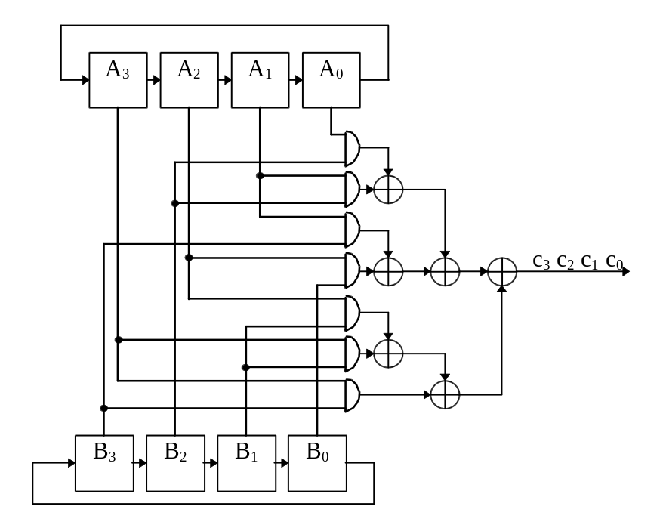
Figure 2.3. Bit-serial Massey-Omura multiplier for GF(2⁴).

In the case of a Massey-Omura multiplier for GF(2⁴), from equ(2.18) seven 2-input AND gates and six 2-input XOR gates are required to implement the required Boolean equation. In general there is a result that states the defining Massey-Omura function for a GF(2^{m}) multiplier requires at least (2m-1) 2-input AND gates and at least (2m-2) 2-input XOR gates [39]. In the case of the above example, it can be seen that the GF(2⁴) Massey-Omura multiplier has achieved this lower bound.

Polynomial basis multipliers
Polynomial basis multipliers operate entirely over the polynomial basis and require no basis converters. These multipliers are easily implemented, reasonably hardware efficient and the time taken to produce the result is the same as for Berlekamp or Massey-Omura multipliers. In truth however bit-serial polynomial basis multipliers are serial-in parallel-out multipliers. In some applications this results in an additional register being required and adds an extra m clock cycles to the computation time. This is the main reason why polynomial basis multipliers are frequently overlooked for use in codec design. However as will be shown in Sections 2.4.5 and 2.4.6, this feature can be actually beneficial.

There are two different methods of operation for polynomial basis multipliers, least significant bit (LSB) first or most significant bit (MSB) first. Either of these approaches may be chosen and both modes are described below.

Option L - LSB first
In this option the LSB appears first on the multiplier input. Therefore denote this multiplier a Bit-Serial Polynomial Basis Multiplier option L (SPBML). This multiplier is described in detail in the literature [4], ([29], pp.163 -164), ([30], pp. 90-91) and summarised here.
Let a, b, c ∈ GF(2^{m}) and represent these elements over the polynomial basis as
a = a₀ + a₁α + ... + a_{m-1}α^{m-1}
b = b₀ + b₁α + ... + b_{m-1}α^{m-1}
c = c₀ + c₁α + ... + c_{m-1}α^{m-1} (2.19)
The multiplication c = a * b can be expressed as
c = a * b = (a₀ + a₁α + ... + a_{m-1}α^{m-1}) * b
c = (...(((a₀b) + a₁bα) + a₂bα²) + ...) + a_{m-1}bα^{m-1} (2.20)
A circuit carrying out multiplication by implementing equ(2.20) therefore requires an LFSR to carry out multiplication by α. This LFSR is initialised with b and on clocking the register the value of bα is generated. The values a₀ ,a₁, ... , a_{m-1} are fed in series into the multiplier to generate each of the values a_{i}bα^{i} (i=0,1,...,m-1) which are accumulated in a register to form the product bits c₀ ,c₁, ... , c_{m-1}. As an example, a circuit diagram for such a multiplier for GF(2³) using the primitive polynomial p(x) = x³ + x + 1 is given in Fig. 2.4.

The operation of this circuit is as follows. The registers are initialised by B_{i} = b_{i} and C_{i} = 0 (i=0,1,2). The values a₀ ,a₁, a₂ are fed in series into the multiplier and after 3 clock cycles the result c is available in the C_{i} register.
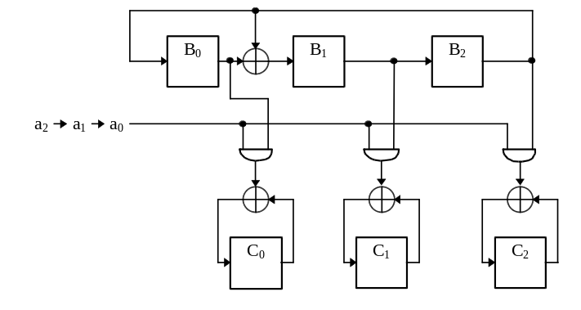
Figure 2.4. Circuit for multiplying two elements in GF(2³).

Option M - MSB first
In this option the MSB appears first on the multiplier input. The Bit-Serial Polynomial Basis Multiplier option M (SPBMM) has been known for many years [28]([29], p.163) and more recently modified by Scott et al [45].
The multiplication c = a * b (where a, b, c are as given in equation 2.18) can be expressed
c = a * b = (a₀ + a₁α + ... + a_{m-1}α^{m-1}) * b
c = (...(((a_{m-1}b)α + a_{m-2}b)α + a_{m-3}b)α + ...)α + a₀b. (2.21)
A circuit implementing equation 2.21 for GF(2³) is shown in Fig. 2.5. Initially the C_{i} register is set to zero and the B_{i} register is initialised by B_{i} = b_{i} (i=0,1,2). a₂ is then fed into the circuit and a₂b loaded into the top register. Then a₁ enters the circuit and the top register are clocked so that they then contain (a₂bα + a₁b). Finally, the top register are clocked to generate (a₂bα + a₁b)α and this value is added to a₀b to form the required product. In general therefore the result is obtained in the C_{i} register after m clock cycles.
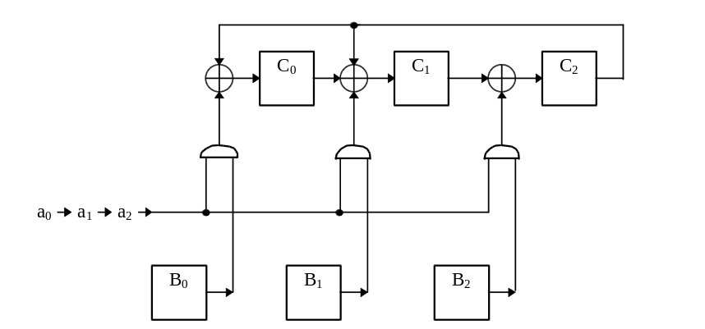
Figure 2.5. Circuit for multiplying two elements in GF(2³).

Comparison of bit-serial multipliers
The Massey-Omura multiplier operates entirely over a normal basis and so no additional basis conversions are required. The normal basis representation is especially effective in performing operations such as squaring. Unfortunately, the multiplier circuit is relatively hardware inefficient (compared to the Berlekamp multiplier for example, [24, 33]) and cannot be hardwired to carry out reduced complexity constant multiplication. Furthermore, the Massey-Omura multiplier cannot be easily extended for different values of m given a particular choice of m.

The Berlekamp multiplier is known to have very low hardware requirements [24]. The Berlekamp multiplier can also be hardwired to allow for particularly efficient constant multiplication [3]. The disadvantage of this multiplier is that it operates over both the dual and the polynomial basis, and so basis converters may be required. In most cases the basis conversion is only a permutation of the basis coefficients, and hence no additional hardware is required (see Appendix C). Because of these reasons, the Berlekamp multiplier is widely used in codec design.

The bit-serial polynomial basis multipliers do not require basis converters, and are almost as hardware efficient as the Berlekamp multiplier. They do however have a different interface to the Berlekamp multiplier being serial-in-parallel-out. Hence the choice between a Berlekamp and a polynomial basis multiplier often depends on the circuit in which the multiplier is to be implemented. For example if the result is required to be represented in parallel then an SPBMM may be used, otherwise a Berlekamp multiplier could be rather adopted.

In comparing all four multipliers directly, it is noted that they each take m clock cycles to generate a solution. Similarly they each require 2m flip-flops. In order to compare the hardware requirements of these four multipliers some notation is introduced. Let Na equal the number of 2-input AND gates required by a multiplier and let Nx equal the number of 2-input XOR gates required by a multiplier. Furthermore, let Da and Dx be the delays through a 2-input AND gate and XOR gate respectively. Let H(pp) be the Hamming weight of the primitive polynomial chosen for GF(2^{m}). (These choices of p(x) are listed in Appendix A.) The hardware requirements and delays of three of these multipliers are given in below.

Berlekamp multiplier
Na = m; Nx = m + H(pp) - 3
Delay = Da + ⎡log₂(m -1)⎤ * Dx. (2.22)
Standard basis multiplier option L
Na = m Nx = m + H(pp) - 2
Delay = Da + Dx. (2.23)
Standard basis multiplier option M
Na = m Nx = m + H(pp) - 2
Delay = Da + 2Dx. (2.24)

For Massey-Omura multipliers the number of gates cannot be explicitly specified. As a comparison, values of Na and Nx for all three types of multiplier are given in Table 2.1

m | Massey Omura [33] |  | Berlekamp |  | SPBML/ SPBMM
 | Na | Nx | Na | Nx | Na | Nx
3 | 5 | 4 | 3 | 3 | 3 | 4
4 | 7 | 6 | 4 | 4 | 4 | 5
5 | 9 | 8 | 5 | 5 | 5 | 6
6 | 11 | 10 | 6 | 6 | 6 | 7
7 | 19 | 18 | 7 | 7 | 7 | 8
8 | 21 | 20 | 8 | 10 | 8 | 11
9 | 17 | 16 | 9 | 9 | 9 | 10
10 | 19 | 18 | 10 | 10 | 10 | 11
Table 2.1 The usage of gates for bit-serial Massey Omura, Berlekamp and standard basis multipliers.
It should be noticed that in some applications the most important feature of a multiplier is the input/output interface. Beth et. al. [4] presented a different interface for polynomials, dual and normal basis multipliers. In conclusion polynomial basis multipliers can be only serial-in parallel-out, whereas dual and normal basis multipliers can be either parallel-in serial-out or serial-in parallel-out.

Generating the sum of products
Often in BCH and RS decoders one product is not required to be generated in isolation, but instead a sum of products must be calculated. For example an equation of the form
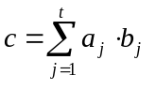 (2.25)
is required to be evaluated in Berlekamp-Massey algorithm circuits described in the next chapter.

If bit-serial Berlekamp or Massey-Omura multipliers are being used, the sum of t products is obtained by the modulo 2 addition of the output of the t independent multipliers and so (t-1) additional XOR gates are required. With polynomial basis multipliers where the outputs are represented in parallel, m*(t-1) XOR gates are required. However if SPBMMs are used to generate these products, large hardware savings can be made, as follows. A SPBMM implements equ(2.21) (rewritten below)
c = (...(((a_{m-1}b)α + a_{m-2}b)α + a_{m-3}b)α + ...)α + a₀b
by generating the values P_{n} = P_{n-1}α + a_{m-n}b (n=1,2,...,m) where P₀ = 0 and c = P_{m}. If now a_{j} = a_{j,0} + a_{j,1}α + ... + a_{j,m-1}α^{m-1} and b_{j} = b_{j,0} + b_{j,1}α + ... + b_{j,m-1}α^{m-1} (j=1,2,...t) then instead generate
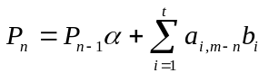 (2.26)
where P₀ = 0 and so 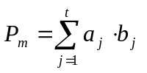.

Equ(2.26) can be implemented by a circuit comprising two parts. Part A generates P_{n-1}α in the same manner that P_{n-1}α is generated in the top register in Figure 2.5. Part B comprises t registers and m 2-input AND gates generating the values a_{i,m-n}b_{i} (n=1,2,...,m) for (i=1,2,...,t). The additions required in equ(2.26) can be carried out by m*(t-1) XOR gates included in the design of the Part A circuit. A circuit for GF(2³) with t=2 is shown in Figure 2.6.

Using this approach to evaluating equ(2.25) (t+1)*m flip-flops are required. If t distinct SPBMMs are used however, 2t*m flop flops are needed and so the above method allows for a saving of (t-1)*m flip-flops to be made. Given that Berlekamp multipliers are the most hardware efficient bit-serial multipliers it would seem appropriate to use these multipliers when implementing equ(2.25). In this case however the presented approach would again save (t-1)*m flip-flops since t distinct multipliers would be required. In addition (H(pp)-2)* (t -1) - 1 XOR gates are saved where H(pp) is the hamming weight of irreducible polynomial for the field. Hence the presented approach is the most hardware efficient method of implementing equ(2.25) currently available.

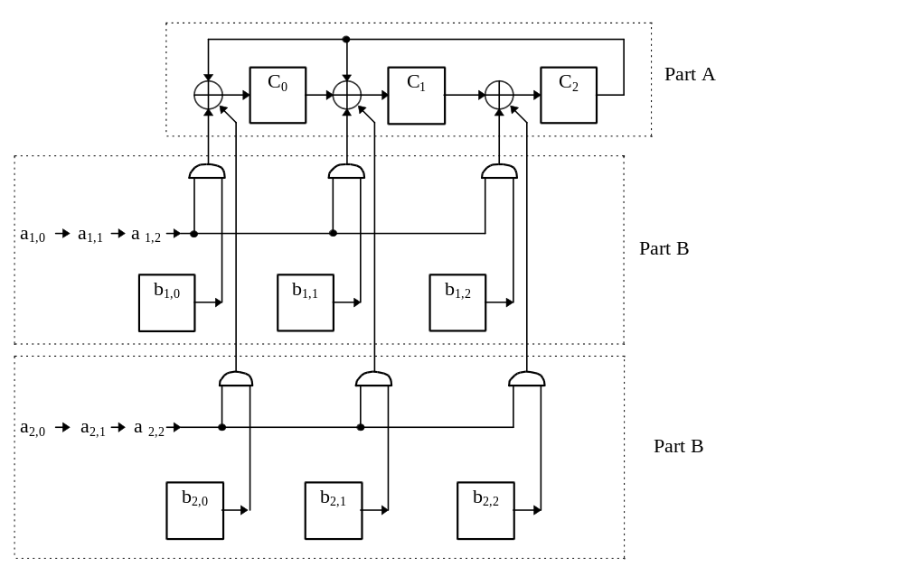
Figure 2.6. Circuit generating c = a₁b₁ + a₂b₂ using in GF(2³) .

Initially the presented approach appears to have an unattractive input/output format since the a_{j} values enter in series, the b_{j} values enter in parallel and the output is also generated in parallel. However when utilised in a Berlekamp-Massey algorithm circuit, this input/output format can be very convenient. This is because the incoming syndromes are frequently represented in series (and so can take the role of the a_{j} values) and the error location values generated by the circuit are represented in parallel (and so can take the role of the b_{j} values). The other multipliers required in the circuit must then also be bit-parallel multipliers, thereby increasing the throughput of the overall circuit. Furthermore in the next section a new approach of Dual Polynomial Basis Multiplier is presented, and a combination of these two architectures offers a new hardware and time efficient architecture for the BMA (presented in Section 3.4.2).

It should be noticed here that sum of products architecture may be also extended for dual and normal basis multipliers if their architecture is serial-in parallel-out. Therefore it is possible to construct a sum of products multiplier for MSB-first dual basis multipliers (Fig. 7 [4]) and for MSB-first and LSB-first normal basis multipliers (Fig. 10, 11 [4]).

Dual-Polynomial Basis Multipliers
In real time applications, the time taken by a multiplier to generate a solution is one of its most important characteristics. Therefore a designer has to choose between hardware efficient but slow bit-serial multipliers, and quick but rather complex bit-parallel multipliers. In some applications it is required to calculate
y = a * b * c. (2.27)
In the standard approach to generate equ(2.27), two multiplications are carried out independently, i.e. first the multiplication z = a * b is implemented and the result stored in the auxiliary register Z, and then the multiplication y = z * c is carried out. The total calculation time is the sum of two independent multiplication times. In some applications this time is unacceptably long and a parallel multiplier must be employed, and so a more complex architecture is required.

To overcome this problem, a new approach has been developed. Using the two proposed Dual-Polynomial Basis Multipliers (DPBMs), the time required to implement equ(2.27) is almost the same as the time required to carry out a single multiplication. Furthermore a DPBM is almost as hardware efficient as the standard bit-serial approach. The DPBM can also be modified to carry out more complex operations such as y = (a * b + c) * d. (This operation is required to be carried out in the Berlekamp Massey algorithm).

Option A dual polynomial basis multipliers
The Berlekamp multiplier can be described as a parallel-in serial-out multiplier. On the other hand, bit-serial polynomial basis multipliers are serial-in parallel-out. Therefore, there is the option of connecting these two types of multiplier together to form one multiplier generating y = a * b * c. In this arrangement, the Berlekamp multiplier’s output is connected directly to the polynomial basis multiplier’s serial input. Thus the multiplication y = a * b * c is carried out in the same time span that a single bit-serial Berlekamp multiplier takes to yield one product. A problem occurs however because the polynomial basis multiplier operates on the polynomial basis whilst the Berlekamp multiplier produces a result in the dual basis, and so an additional basis conversion is required.

The complexity of this basis representation depends on the irreducible polynomial selected, and so two cases have been considered. Those cases in which the irreducible polynomial for the field is
- a trinomial of the form p(x) = x^{m} + x^{p} + 1, or
- a pentanomial of the form p(x) = x^{m} + x^{p+2} + x^{p+1} + x^{p} + 1.

Irreducible trinomials
When the irreducible polynomial defining GF(2^{m}) is a trinomial, the dual basis is a permutation of the polynomial basis (see Appendix C). Therefore it is possible to rearrange the order of the output from the Berlekamp multiplier so that it is compatible with the polynomial basis multiplier.

As an example, consider GF(2⁴) with p(x) = x⁴ + x + 1. An element z ∈ GF(2⁴) is represented in the polynomial basis as
z = z₀+ z₁α + z₂α² + z₃α³ z_{i} ∈ GF(2) (2.28)
so a Berlekamp multiplier would generate this value in the dual basis as z₀, z₃, z₂, z₁.
The SPBMM requires the serial input in the order
z₃, z₂, z₁, z₀.
A circuit that rearranges the dual basis coefficients into this order can be easily developed, thus allowing the DPBM to be designed. The general scheme for a multiplier generating y = a * b * c is shown in Figure 2.7.

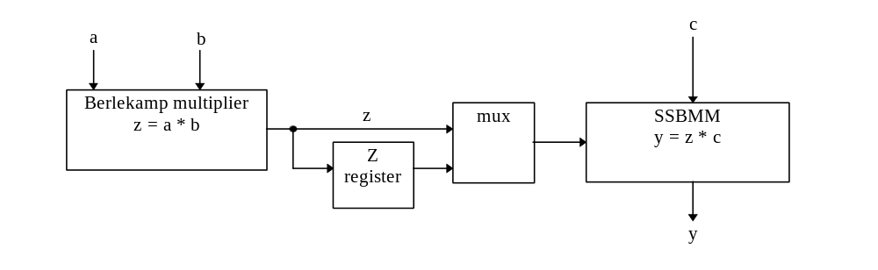Figure 2.7. Dual-Polynomial Basis Multiplier option A.
Assume for instance that the multiplier shown in Figure 2.7 is a Dual-Polynomial Basis Multiplier option A (DPBMA) for GF(2⁴). The hardware required in addition to the SPBMM and the Berlekamp multiplier is a 2:1 multiplexer and a flip-flop. On the first clock cycle the values of a and b are parallel loaded into the Berlekamp multiplier. Once these values have been stored, the first product bit z₀ is available on the output. This result is then clocked into the Z flip-flop. On clocking the Berlekamp multiplier a further three times the values of z₃, z₂, z₁ are produced. These coefficients pass through the multiplexer and feed the serial input of the SPBMM. On the 5th clock cycle the multiplexer feeds the SPBMM input with z₀, so that the SPBMM has been fed the input sequence z₃, z₂, z_{1,} z₀, as required. In total therefore this circuit has a total computation time of (m+1) clock cycles. Note also that no extra m-bit register Z is required to store the value of z as required in the standard approach to generating equ(2.27).

This approach may be easily extended to GF(2^{m}) where the irreducible polynomial for GF(2^{m}) is of the form p(x) = x^{m} + x^{p} + 1. In this case if (z₀, z₁, ..., z_{m-1}) is the polynomial basis representation of z ∈ GF(2^{m}), the output in the dual basis from a Berlekamp multiplier is (see Appendix C)
z_{p-1}, z_{p-2}, ..., z₀, z_{m-1}, z_{m-2}, ..., z_{p} . (2.29)
In this case, a multiplier structure similar to that shown in Figure 2.7 is derived. In addition, p extra flip-flops and one (p + 1):1 multiplexer are required, and the total calculation time is now m + p clock cycles.

Irreducible pentanomial
When the irreducible polynomial for GF(2^{m}) is a pentanomial of the form
p(x) = x^{m} + x^{p+2} + x^{p+1} + x^{p} + 1
the dual to polynomial basis conversion involves a reordering and two GF(2) additions, and so two extra XOR gates are required to implement this conversion. In this case the DPBMA is more difficult to implement, but is still worthy of consideration.

As an example, and because GF(2⁸) is the most useful example of a field for which an appropriate pentanomial exists, consider GF(2⁸) with p(x) = x⁸ + x⁴ + x³ + x² + 1. Let z ∈ GF(2⁸) be presented in the dual basis as
z = z₀μ₀ + z₁μ₁ + z₂μ₂ + z₃μ₃ + z₄μ₄ + z₅μ₅ + z₆μ₆ + z₇μ₇ z_{i} ∈ GF(2)
and in the polynomial basis as
z = s₀ + s₁α + s₂α² + s₃α³ + s₄α⁴ + s₅α⁵ + s₆α⁶ + s₇α⁷. s_{i} ∈ GF(2)

Then the dual to polynomial basis conversion is given by
s₇ ← z₃, s₆ ← z₄ , s₅ ← z₅, s₄ ← z₆
s₃ ← z₃ + z₇, s₂ ← z₀ + z₂ , s₁ ← z₁, s₀ ← z₂.
The DPBMA for GF(2⁸) is shown in Figure 2.8.
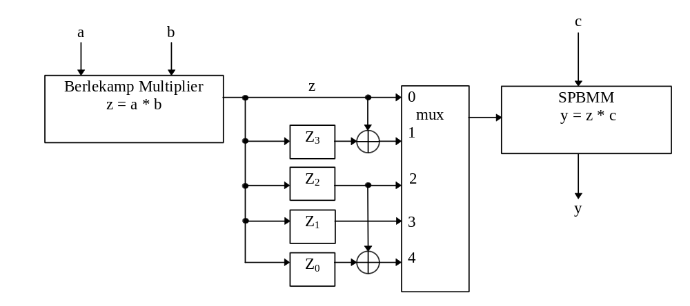
Figure 2.8. DPBMA generating y = a * b * c in GF(2⁸)
The operation of the DPBMA shown in Figure 2.8 is as follows. On the first clock cycle a and b are parallel loaded into the Berlekamp multiplier and at this point the first product bit is available on the output. The remaining 7 product bits are obtained by clocking the Berlekamp multiplier a further 7 times. The first 4 values generated by the Berlekamp multiplier are clocked into the Z_{i} register so that after 4 clock cycles Z_{i} = z_{i} (i=0,1,2,3). This fourth value of z₃ is also the first input to the SPBMM (i.e. s₇). The next three outputs from the Berlekamp multiplier are fed into the SPBMM and then the multiplexer selects inputs 1,4,3,2 on the next four clock cycles to generate the required input for the SPBMM. The overall DPBMA will generate a solution on the 11th clock cycle.

In general, a DPBMA takes m+p+1 clock cycles to generate a product when the irreducible polynomial is of the form p(x) = x^{m} + x^{p+2} + x^{p+1} + x^{p} + 1. In addition to the required Berlekamp multiplier and the SPBMM, an additional p+2 flip-flops, two 2-input XOR gates and one (3+p):1 multiplexer are required.

Dual polynomial basis multipliers option B
The DPBM may also be developed in a different form. With this option, a multiplier implementing equ(2.27) has the same calculation time as a single, bit-serial multiplier. Instead of rearranging the order of the output from a Berlekamp multiplier, it is possible to add an additional circuit to the input of a ‘Berlekamp-like’ multiplier denoted bit-serial dual basis multiplier (SDBM). With this scheme, the SDBM produces a product in the polynomial basis, and so no extra circuit between the SDBM and the SPBMM is required. In order to develop the DPBM option B (DPBMB), the function Rd(x) is introduced.

Definition 2.6. Let the irreducible polynomial for GF(2^{m}) be p(x) = p₀ + p₁x + p₂x² + ... + x^{m} and let a, b ∈ GF(2^{m}) be represented in the dual basis as
b = b₀μ₀ + b₁μ₁ + ... + b_{m-1}μ_{m-1}
a = a₀μ₀ + a₁μ₁ + ... + a_{m-1}μ_{m-1}.
Then define the function Rd : GF(2^{m}) → GF(2^{m}) such that b = Rd(a), where b satisfies
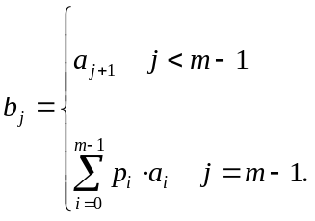 (2.30)
The value b = Rd(a) = aα where α is a root of p(x) and so the function Rd(x) has the same effect of the coefficients of x as an LFSR which is initialised with the dual basis representation of x. Let Rd²(a) be defined as Rd²(a) = Rd(Rd(a)) - the state of the LFSR after 2 clock cycles - and so on.

Irreducible trinomials
To introduce the DPBMB assume first that the defining irreducible polynomial p(x) is a trinomial of the form p(x) = x^{m} + x^{p} + 1. Now consider a Berlekamp multiplier without the LFSR but instead a set of m input lines A_{i}, denoted as SDBM.

Let a, b, z ∈ GF(2^{m}) such that z = a * b. Further, let b and z be represented in the polynomial basis and a be represented in the dual basis as a = a₀ + a₁α + ... + a_{m-1}α^{m-1}. If the SDBM is fed with the inputs A_{i} = a_{i} (i=0,1, ..., m-1) the first coefficient of the dual basis representation of z is obtained, or equivalently from equ(2.29), the p-th polynomial basis coefficient of z, namely z_{p-1}. So if instead, the multiplier is fed with the dual basis representation of Rd^{p}(a), the p+1-th coefficient of the dual basis representation of z is obtained, or equivalently, the last polynomial basis coefficient z_{m-1}. Similarly, if on the next clock cycle the multiplier is fed with the dual basis representation of Rd^{p+1}(a), the p+2-th coefficient of the dual basis representation of z is obtained, or equivalently, the next to the last polynomial basis coefficient z_{m-2}. This analysis may continue and so overall, if the proposed multiplier is fed with the input sequence
Rd^{p}(a), Rd^{p+1}(a), Rd^{p+3}, ..., Rd^{m-1}(a), a, Rd(a), ..., Rd^{p-1}(a) (2.31)
the multiplier will generate the values z_{m-1}, z_{m-2}, ... , z₀ which is the correct format for the SPBMM.

As previously mentioned the proposed technique is flexible in that it can be modified to carry out operations of the form y = (a * b + c) * d. For example, consider Figure 2.9 where a circuit for GF(2⁴) is presented implementing the operation y = (a * b + c) * d. Consider first the lower half of the circuit which implements z = a*b using a SDBM. Taking p(x) = x⁴ + x^{p} + 1, (p=1) in order that the SDBM produces the result in the required sequence, from equ(2.31) the ‘a’ inputs to the multiplier must be in the order
Rd(a), Rd²(a), Rd³(a), a.
To achieve this four flip-flops, four 3:1 multiplexers, an Rd^{p}(a) circuit and an Rd(a) circuit are additionally required. (An Rd^{p}(a) circuit is a combinational circuit that given the dual basis representation of a ∈ GF(2^{m}), generates Rd^{p}(a). This circuit therefore implements a linear transformation over GF(2) and comprises p XOR gates. In this case, it can be seen that only one additional XOR gate is required).

On the first clock cycle, the multiplexers select input 0, thereby loading Rd^{p}(a) into the ar_{i} register. On the 2nd and 3rd clock cycles the multiplexers select input 2 thereby loading Rd²(a) and Rd³(a) respectively into the ar_{i} register. Finally on the 4th clock cycle, the multiplexers select input 1 to load the dual basis representation of a into the ar_{i} register. In doing this the output sequence z₃, z₂, z₁, z₀ is generated, as required by the SPBMM.

If the C_{i} register was previously initialised with the polynomial basis coefficients of c and are now clocked, the polynomial basis representation of (a*b + c) is generated. This value is then fed into an SPBMM as normal to generate the required result y = (a*b + c)*d, this equation is required in the BMA.

The DPBMB can be easily extended to different GF(2^{m}) if the irreducible polynomial is a trinomial of the form p(x) = x^{m} + x^{p} + 1. In general, the multiplexers should select the following signals.

Clock cycle | Origin of Signal | Actual Values on  these Signals
1 | Rd^{p}(a) circuit | Rd^{p}(a)
2 to m-p | Rd(a) circuit | Rd^{p+1}(a) to Rd^{m-1}(a)
m-p+1 | A_{i} register | a
m-p+2 to m | Rd(a) circuit | Rd(a) to Rd^{p-1}(a)

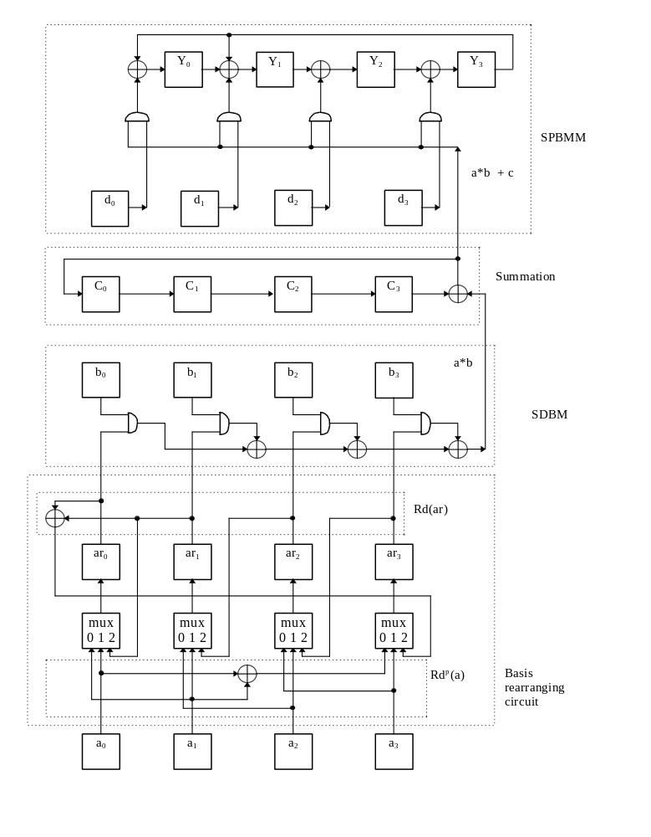Figure 2.9 Circuit generating y = (a * b + c) * d in GF(2⁴).

In comparison with a standard approach, a DPBMB circuit requires an additional m 3:1 multiplexers, m flip-flop, one XOR gates to form the Rd(x) circuit and p XOR gates to generate the Rd^{p}(x) circuit. In order to reduce the complexity of this Rd^{p}(x) circuit, a value of p as low as possible should be chosen. Hence the optimal irreducible polynomial to choose in this instance is p(x) = x^{m} + x + 1. Such polynomials exist for m=2,3,4,6,7, etc.

Primitive pentanomials
When the irreducible polynomial p(x) is of the form p(x) = x^{m} + x^{p+2} + x^{p+1} + x^{p} + 1 an DPBMB can be designed similarly as in the trinomial case. Because the basis conversion is not just a permutation of basis coefficients and also involves two GF(2) additions, the circuit rearranging the input to a SDBM is rather more complicated however.

Using the same analysis as in the trinomial case, it can be shown that when p(x) = x^{m} + x^{p+2} + x^{p+1} + x^{p} + 1, the required input sequence for an SDBM multiplier is
Rd^{p+1}(a), Rd^{p+2}(a), ... , Rd^{m-2}(a), Rd^{p+1} + Rd^{m-1}(a), a + Rd^{p}(a), Rd(a), ... , Rd^{p}(a).

So for example consider GF(2⁸) and p(x) = x⁸ + x⁴ + x³ + x² + 1. The required input sequence is therefore
Rd³(a), Rd⁴(a), Rd⁵(a), Rd⁶(a), Rd³(a)+Rd⁷(a), a+Rd²(a), Rd(a), Rd²(a).
This sequence is generated by a circuit of the form shown in Figure 2.10. The key section of this circuit is the multiplexer determining the ordering of the above input sequence. The input selection lines are as follows:

clocks 1 line 4 Rd³(a)
clock 2-4 line 3 Rd(ar) i.e. Rd⁴(a), Rd⁵(a), Rd⁶(a)
clock 5 line 2 Rd(ar) + Rd³(a) i.e. Rd⁷(a) + Rd³(a)
clock 6 line 1 Rd²(a) + a
clock 7 line 0 Rd(a)
clock 8 line 3 Rd(ar) i.e. Rd²(a),

In general, the DPBMB requires an additional (p+2) Rd(x) circuits (3 XOR gates in each), 2m XOR gates for summation circuits, m 5:1 multiplexers and m flip-flops.

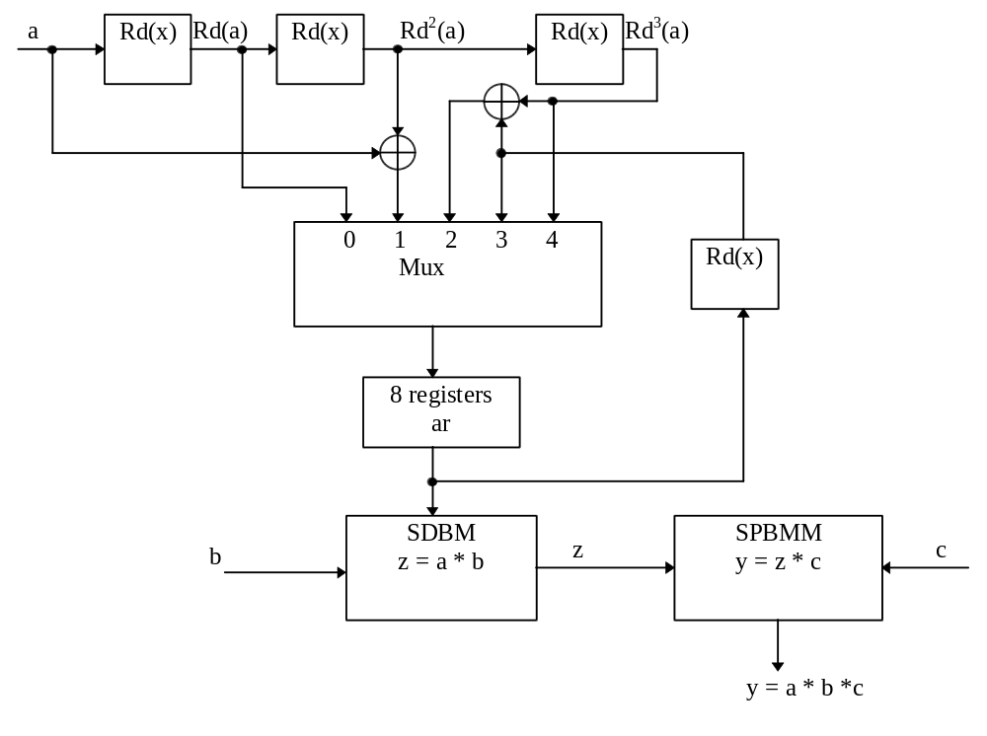
Figure 2.10. DPBMB generating y = a * b * c in GF(2⁸)

Summary of DPBM
The DPBM is particularly useful if the time taken to generate a product is critical. The DPBM offers a half-way solution between a bit-serial and a bit-parallel multiplier. Furthermore, both DPBMs are hardware efficient and in some situations the DPBM offers a reduction in hardware since the intermediate value z does not have to be stored. The structure of the DPBM depends on the irreducible polynomial for GF(2^{m}). The optimal irreducible polynomial is a trinomial of the form p(x) = x^{m} + x^{p} + 1 where p = 1, for p>1, more hardware is required in the multiplier. For some values of m (e.g. m = 8) there do not exist irreducible trinomials, and so an irreducible pentanomial must be used resulting in the addition of extra hardware. Although, the structure of the DPBM depends on the selected irreducible polynomial for GF(2^{m}), it has been shown that the architecture can be easily specified for two important classes of irreducible polynomials.

The DPBMs require only one input to be represented in the dual basis, the other input and the output are represented in the polynomial basis. Two different options have been presented. With the DPBMA, the dual basis output is converted into the polynomial basis. This multiplier is particularly suited to generating products of the form y = a * b * c or y = (a * b + c) * d if it is acceptable to take (m+p) clock cycles to generate this product. With the DPBMB the basis rearranging takes place on the input. This approach takes more hardware than the DPBMA circuit, but generating the product only takes m clock cycles.

The DPBMB is of particular use when evaluating expressions of the form
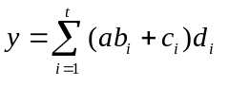 (2.32)
where a, b_{i}, c_{i}, d_{i} ∈ GF(2^{m}). This is because only one relatively expensive basis rearranging circuit is required. Expressions of the type equ(2.32) are generated in the implementation of the Berlekamp-Massey algorithm.

Note that SPBMLs have not been used in conjunction with DPBMs because the basis reordering circuits are more complicated than the ones needed when using SPBMMs.

Beth et. al. [4] presented normal basis multipliers with a LSB-first serial-in parallel-out interface. Therefore it is also possible to construct a multiplier that can carry out the multiplication d= a * b * c over the normal basis during only m clock cycles. This multiplier consists of a parallel-in serial-out Massey-Omura multiplier of the form presented in Section 1.4.2. and the above multiplier ([4] Fig. 11). This double - multiplier does not require basis rearranging as the DPBM does, but normal basis multiplication is relatively hardware inefficient (see Section 2.4.4), and constructing a normal basis multiplier for different choices m is quite complex. In addition, a normal basis multiplication requires the arguments of the multiplication to be rotated therefore an additional control system is required. Summing up, in this thesis the DPBM is adopted, however in some instances it is not obviously the most appropriate architecture.
A similar architecture using only dual basis multipliers cannot be constructed, because parallel-in serial-out multipliers produce the result in the dual basis and the serial-in parallel-out dual basis multipliers can be constructed only for serial input in the polynomial basis [4].

Bit-Parallel Multiplication
In some applications, it is required to adopt bit-parallel architectures rather than bit-serial ones to achieve the required performance. So far, only bit-serial multipliers have been considered because of their hardware advantages over bit-parallel multipliers. Unfortunately, in the time critical places in BCH codecs, bit-serial architectures are too slow and more complex bit-parallel architecture must be adopted.

Dual Basis Multipliers
The bit-parallel dual basis multiplier (PDBM) was presented in [15]. Let a, c ∈ GF(2^{m}) be represented in the dual basis by a = a₀μ₀ + a₁μ₁ + ... + a_{m-1}μ_{m-1} and c = c₀μ₀ + c₁μ₁ + ... + c_{m-1}μ_{m-1}. Let b ∈ GF(2^{m}) be represented in the polynomial basis as b = b₀ + b₁α + ... + b_{m-1}α^{m-1}. The multiplication c = a * b is therefore represented by equations (2.16) and (2.17). Using these equations and the bit-serial Berlekamp multiplier properties, the PDBM can be easily derived [15] as a circuit implementing the equations
c_{j} = a_{j}b₀ + a_{j+1}b₁ + a_{j+2}b₂ + ... + a_{j+m-1}b_{m-1} (j=0,1,....,m-1)
a_{m+k} = 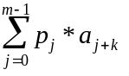 (k=0,1,...,m-1) (2.33)
where the p_{j} are the coefficients of the primitive polynomial for the field p(x) = p₀ + p₁x + ... + x^{m}.

In general therefore a PDBM for GF(2^{m}) comprises one type A module that generates a_{m+i} (i=0,1,...,m-1) from equ(2.33) and m type B modules each generating the inner product of two m-length vectors over GF(2). As an example, the PDBM for GF(2³) using p(x) = x³ + x + 1 is given below.
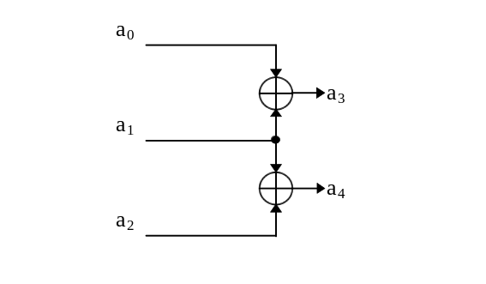
Figure 2.11. Type A module for a bit-parallel dual basis multiplier for GF(2³).
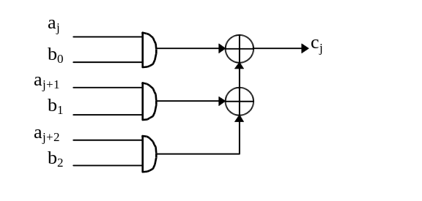
Figure 2.12. Type B module for a bit-parallel dual basis multiplier for GF(2³).
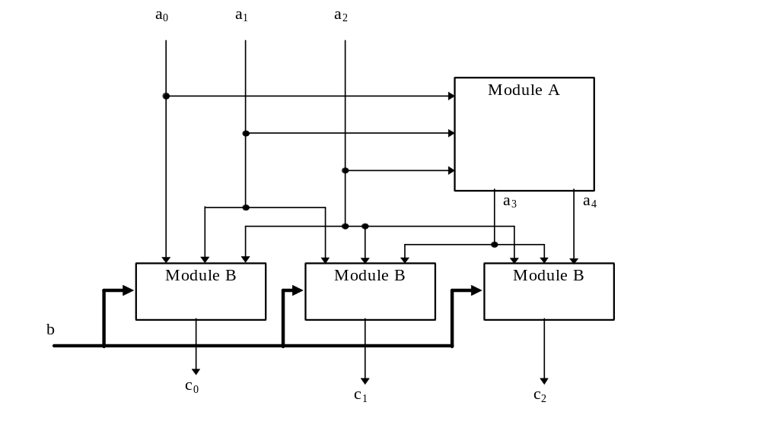
Figure 2.13. Bit-parallel dual basis multiplier for GF(2³).

Normal basis multipliers
A bit-parallel normal basis multiplier was also presented by Massey and Omura [31]. This multiplier comprises m identical Boolean functions, where the inputs to these functions are effectively cyclically shifted one each time. A bit-parallel Massey-Omura multiplier (PMOM) requires at least m(2m-1) 2-input AND gates and at least m(2m-2) 2-input XOR gates [31,54]. The complexity of this multiplier is therefore dependent upon the complexity of the defining multiplication function. Accordingly, this multiplier is more hardware intensive than the PDBM and is not used in this thesis.

Polynomial Basis Multipliers
The bit-parallel polynomial basis multiplier (PPBM) was presented by Laws et al. [28]. The multiplier performs the same sequence of computations as the bit-serial polynomial multiplier option M (SPBMM), and so denote this multiplier the parallel polynomial basis multiplier option M (PPBMM).
Let a, b, c∈ GF(2^{m}) and
a = a₀ + a₁α + ... + a_{m-1}α^{m-1}
b = b₀ + b₁α + ... + b_{m-1}α^{m-1}
c = c₀ + c₁α + ... + c_{m-1}α^{m-1}. (2.34)
To generate c = a * b, the representation
c = (...(((a_{m-1}b)α + a_{m-2}b)α + a_{m-3}b)α + ...)α + a₁b (2.35)
is again used. The PPBMM therefore consists of (m-1) blocks that carry out the operations
y_{m-1}= a_{m-1}b
and y_{j} = a_{j}b + y_{j+1}α mod p(α). for m-1> j ≥0
where the result c = y₀, and p(x) is the irreducible polynomial for GF(2^{m}).

Mastrovito has presented a different type of polynomial basis multiplier [33]. This multiplier generates
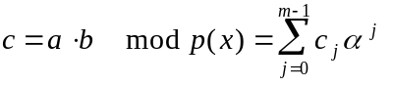
by employing the product matrix M:
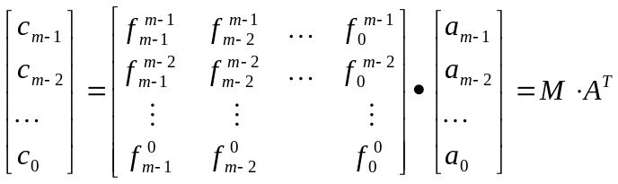 (2.36)
where 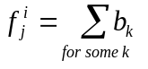.
The most burdensome part of the Mastrovito algorithm is finding the product matrix M. The algorithm for finding the matrix M has been omitted as it is rather complicated and can be found in [33]. In conclusion, the Mastrovito bit-parallel polynomial basis multiplier (MPPBM) is rather difficult to represent algorithmically. However the advantage of the MPPBM is that it has a smaller time delay than the PPBMM.

Laws et al. [28] presented a parallel multiplier using the same calculation sequence as the SPBMM. The question arises, is it possible to construct a modular and regular parallel multiplier employing the same calculation sequence as in the case of the SPBML. Research carried out concludes that it is, as below.

Express the multiplication c = a * b as in equ(2.20)
c = (...(((a₀b) + a₁bα) + a₂bα²) + ...) + a_{m-1}bα^{m-1} .
Now represent b * α^{j} as
b * α^{j} = b_{j,0} + b_{j,1}α + b_{j,2}α² + ... + b_{j,m-1}α^{m-1}. (2.37)
Therefore using (2.20) and (2.37)
c_{j} = a₀b_{0,j} + a₁b_{1,j} + a₂b_{2,j} + ... + a_{m-1}b_{m-1,j} (2.38)
Equation (2.38) may also be derived if the SPBML is considered. In the SPBML, the value c_{j} is obtained by sequentially summing up the binary multiplication b_{j,i} (the state of register b_{i} after j clock cycles) and a_{i}.
Using equations (2.38) and (2.37) it is possible to construct a modular and regular bit-parallel polynomial basis multiplier, option L (PPBML). A PPBML for GF(2⁴) is presented below.
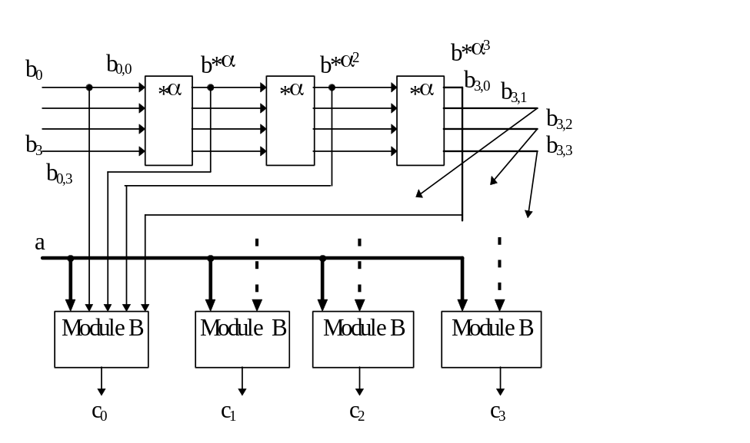
Figure 2.14. PPBML for GF(2⁴).
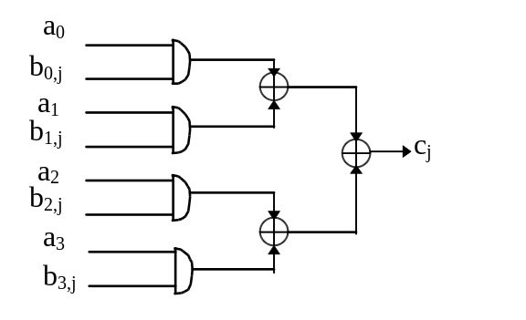
Figure 2.15. Module B of the PPBML - Identical inner product generator identical to that required in the Berlekamp multiplier.
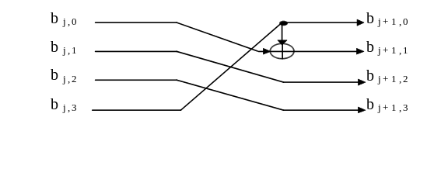
Figure 2.16. Circuit for multiplying by α in GF(2⁴)
In general a PPBML for GF(2^{m}) comprises m type B inner product modules and (m-1) type C modules that generate α^{j} * b where α is a root of p(x) and b ∈ GF(2^{m}). A type C module essentially carries out a linear transformation of basis coefficients over GF(2) and will therefore consist of a number of XOR gates.

Comparison of parallel multipliers
In this section the PDBM [15], the PMOM [31,54] and three polynomial basis multipliers, the MPPBM [33], the PPBMM [28], and the PPBML have been considered. A comparison of the number of XOR and AND gates required by these multipliers and the maximum delay times for a range of values of m are presented below. (In fact, the delay through each of these multipliers is Da plus the values cited below, since a single row of AND gates is also required by each of the multipliers).

m | PMOM |  |  | MPPBM |  |  |  | PDBM  PPBMM  PPBML |  | PDBM | PPBMM | PPBML
 | N_{A} | N_{X} | D_{X} | N_{A} | N_{X} | D_{X} | N_{A} |  | N_{X} | D_{X} | D_{X} | D_{X}
3 | 15 | 12 | 2 | 9 | 8 | 3 | 9 |  | 8 | 3 | 3 | 3
4 | 28 | 24 | 3 | 16 | 15 | 3 | 16 |  | 15 | 3 | 4 | 3
5 | 45 | 40 | 3 | 25 | 25 | 5 | 25 |  | 24 | 5 | 6 | 5
6 | 66 | 60 | 4 | 36 | 33 | 4 | 36 |  | 35 | 4 | 6 | 4
7 | 133 | 126 | 5 | 49 | 48 | 4 | 49 |  | 48 | 4 | 7 | 4
8 | 168 | 160 | 5 | 64 | 90 | 5 | 64 |  | 77 | 7 | 11 | 7
9 | 153 | 144 | 4 | 81 | 80 | 5 | 81 |  | 80 | 6 | 11 | 6
10 | 190 | 180 | 5 | 100 | 101 | 6 | 100 |  | 99 | 6 | 12 | 6

Table 2.2. Comparison of bit-parallel finite field multipliers.

The number of gates for the PMOM is taken from [33], for the MPPBM and the PDBM this number is taken from [15]. The primitive polynomials used to design these multipliers (excluding the PMOM) are listed in Appendix A.

As a general rule, the number of gates and multiplier delay can be obtained from the following:
PDBM:
N_{A}= m*m N_{X}= (m-1)*(m + H(pp)-2) Del= ⎡log₂(m)⎤ + t * ⎡log₂(H(pp)-1)⎤
PPBMM:
N_{A}= m*m N_{X}= (m-1)*(m + H(pp)-2) ( D_{X}= m -1 + t if H(pp)= 3 )
PPBML:
N_{A} = m*m N_{X}= (m-1)*(m + H(pp)-2) ( D_{X}= ⎡log₂(m)⎤ + t if H(pp)= 3 )
where t = ⎡(m-1)/(m-p)⎤ and p(x) = x^{m} + x^{p} + 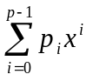.

In conclusion from Table 2.2, the PPBML has the same parameters as the PDBM for the considered choices of m. The PPBML needs no basis conversions and so the design of a PPBML is simpler and more hardware efficient than the PDBM, especially if a primitive trinomial for GF(2^{m}) does not exist. On the other hand, the PDBM is slightly easier to design (without the basis conversions), and some additional design optimisation can be done, e.g. for m= 8 the number of XOR gates can be reduced to 72 [15]. In conclusion, the choice between PDBM and PPBML is related to the individual design specification, as the differences in design complexity and hardware requirements are small.

The PPBMM has the same hardware requirements as the PPBML but a longer delay time. Accordingly the PPBMM is not used in the thesis. Similarly, the PMOM is not used given the high hardware requirements and long delay path of the multiplier. The PPBML in comparison with the MPPBM is much easier to design; and in most cases the final circuits are similar, e.g. for m= 4. Therefore in this thesis only the PDBM and PPBML have been considered.

It should be mentioned that a number of bit parallel multipliers have been proposed for circumstances in which p(x) is of the form p(x) = x^{m} + x^{m-1} + ..... + x + 1, that is, when p(x) is an all one polynomial [22]. However all one polynomials are relatively rare and so do not help in finding general solutions of the kind required here.

Finite field exponentiation

Squaring
In some applications squaring in a finite field is required. Squaring can be performed using a standard multiplier but this approach is rather hardware inefficient. Instead, a different algorithm is employed, as was described for example in [16].
Let a ∈ GF(2^{m}) be represented in the polynomial basis as
a = a₀ + a₁α + a₂α² + ... + a_{m-1}α^{m-1}.
Now let b ∈ GF(2^{m}) such that b = a² . From equ(2.8), f²(x) = f(x²) and so
b = a² = a₀ + a₁α² + a₂α⁴ + a₃α⁶ + ... + a_{m-1}α^{2m-2} mod p(α). (2.39)
In other words, the coefficients of b can be obtained from a linear transformation of the coefficients of a over GF(2). This linear transformation will require a number of XOR gates to implement, and these numbers for a range of m are listed in Table 2.3.

Raising field elements to the third power
The standard approach for carrying out exponentiation to the power three is to use a standard multiplier and squaring and then calculate a³ = a² * a [46]. If a PPBML is used together with the approach for carrying out squaring described above, the hardware requirements for this circuit are as given in Table 2.3.

An alternative method of raising elements to the power three is now described. Let a, b∈ GF(2^{m}) such that b = a³ and represent both these elements over the polynomial basis in the usual way. From the equation
(x + y)³ = x³ + 3x²y + 3xy² + y³
the expressions
b = a³ = (a₀ + a₁α + a₂α² + ... + a_{m-1}α^{m-1})³ mod p(α)
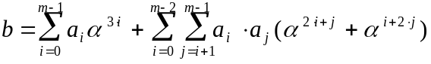 mod p(α) (2.40)
are derived. A circuit implementing equ(2.40) can be designed directly and consists of (m-1) + (m-2) + ... +1 = m*(m-1)/2 AND gates and at most m*(m²-1)/2 XOR gates. However in practice, these requirements are much lower. The number of gates for this cubic circuit is given in Table 2.3. In comparison with the standard approach this method offers hardware savings especially if design optimisation is employed. For example for m = 8, with optimisation the number of XOR gates is almost the halved.

m | squaring | cubic |  | a³ = a² * a
 | N_{XOR} | N_{XOR} | N_{AND} | N_{XOR} | N_{AND}
4 | 2 | 16 (13) | 6 | 17 | 16
5 | 3 | 29 (21) | 10 | 27 | 25
6 | 3 | 47 (33) | 15 | 38 | 36
7 | 3 | 66 (46) | 21 | 51 | 49
8 | 12 (10) | 135 (70) | 28 | 87 | 64
9 | 6 | 133 (83) | 36 | 86 | 81
10 | 6 | 159 (105) | 45 | 105 | 100
Table 2.3. Hardware requirements for exponentiation in GF(2^{m}). ( ) = with design optimisation.

Finite field inversion
BCH decoders are required to implement the finite field division c = a/b. This division can be implemented using a division algorithm e.g. [15, 17, 21]. Unfortunately, BCH decoders require that the result of a division be available faster than these algorithms allow. Often however b is available earlier than a and so it can be beneficial to first employ inversion to generate b⁻¹ and then to use a fast bit-parallel multiplier.

Throughout this thesis, the Fermat inverter is used. Fermat inverters operating over the normal and dual bases have been presented [16, 54]. The dual basis inverter is hardware efficient and what is more, it is convenient that the result of this division is represented in the dual basis and so can be utilised in dual basis multipliers for example. Hence, the dual basis inverter has been employed in this project.

A Fermat inverter implements the equation
(2.41)
and so in turn is based on repeated multiplications and squaring. The dual basis inverter uses a PDBM as presented in Section 2.5.1 and carries out squaring in the polynomial basis as described in Section 2.6.1. The overall inversion circuit requires (m-1) clock cycles to generate a result. To then calculate c = a/b = a*b⁻¹ one extra clock cycle is required to carry out the multiplication.

Conclusions
In this chapter the main definitions and results underpinning finite field theory have been introduced. It has been shown how to generate GF(2^{m}) from the base field GF(2) and the most important basis representations have been described.

The most useful bit-serial and bit-parallel finite field multipliers have been reviewed for adoption in BCH codecs. Circuits for carrying out inversion, division and exponentiation in GF(2^{m}) have also been described. Finally some important new circuits have been presented. A hardware efficient method of generating the sum of products using a previously overlooked multiplier has been described. This circuit operates entirely over the polynomial basis and has an attractive input/output format for use in circuits implementing the Berlekamp-Massey algorithm. Two multiplier circuits generating products of the form y = a*b*c have also been presented. These circuits are based around Berlekamp multipliers and SPBMMs. Hardware/time trade-offs are made in determining which of these two options to adopt. Both multipliers propose novel methods of implementing the required basis conversions so allowing Berlekamp multipliers and SPBMMs to be used in tandem. Finally, a new bit-parallel multiplier - the PPBML - has been presented. This multiplier is a hardware efficient equivalent of a previously presented bit-serial multiplier. In addition, a new algorithm for exponentiation to the power three has been presented. The algorithm is especially hardware efficient if the design optimisation is employed.

